Esther's Closet For Kids

We provide free gently used and new clothes for foster kids. We are currently offering sizes 0 up to 5T.

As former foster parents (we adopted our children out of foster care) we know firsthand the great challenges foster families can face. You can get a call in the middle of the night and have a new child in your home literally within hours. Sometimes that child may only come with the clothes they are wearing. We want foster families to be able to focus on caring for that child instead of trying to figure out how to get them clothes or shoes.
We are located in the Renton Highlands and gladly accept donations of new or gently used clothes and shoes with no rips/stains. To donate or to set up an appointment to come shopping at Esther's Closet for your foster child, email us at esthersclosetforkids@mail.com. Or call Nicole at 425-518-9872. We can help deliver clothing in the case of an emergency placement/situation.

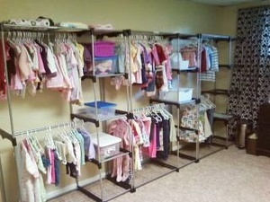

James 1:27
Religion that God our Father accepts as pure and faultless is this: to look after orphans and widows in their distress..

www.esthersclosetforkids.webs.com

